Setting up Transit Gateway and VPC Endpoints for a Multi-VPC Architecture

Step 1: Create VPC-1
- VPC Dashboard → Create VPC
- Name: VPC-1
- CIDR: 10.0.0.0/16
- Create 1 Public Subnet: 10.0.1.0/24

Step 2: Create VPC-2
- Name: VPC-2
- CIDR: 10.1.0.0/16
- Create 1 Public Subnet: 10.1.1.0/24
Step 3: Create VPC-3
- Name: VPC-3
- CIDR: 10.2.0.0/16
- Create 1 Public Subnet: 10.2.1.0/24
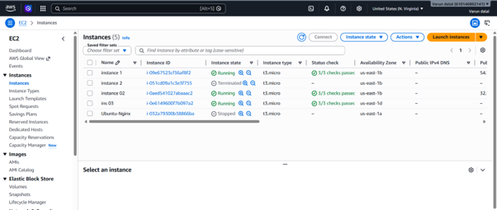

Step 4: Create Internet Gateways
For each VPC:
- VPC → Internet Gateways → Create
- Attach to respective VPC

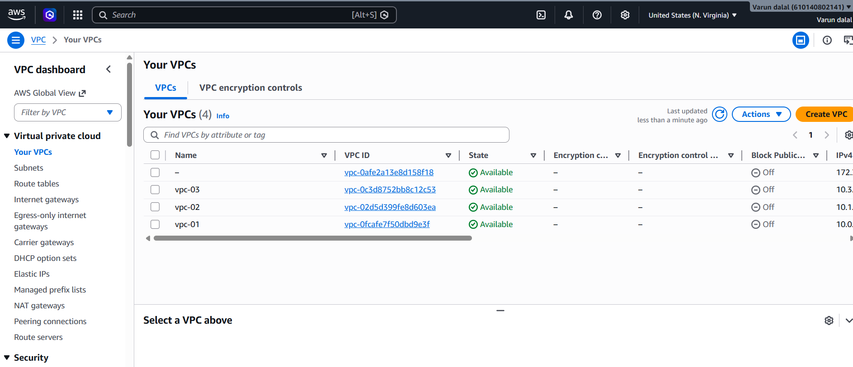 Step 5: Configure Route Tables
For each VPC Route Table add:
0.0.0.0/0 → Internet Gateway
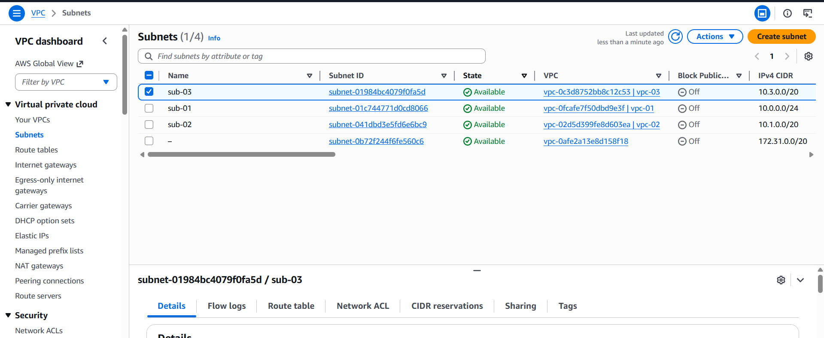

Step 6: Launch EC2 Instances
Launch 1 EC2 in each VPC:
- Amazon Linux 2023
- t3.micro
- Enable Public IP
- Security Group:
  - SSH (22)
  - ICMP

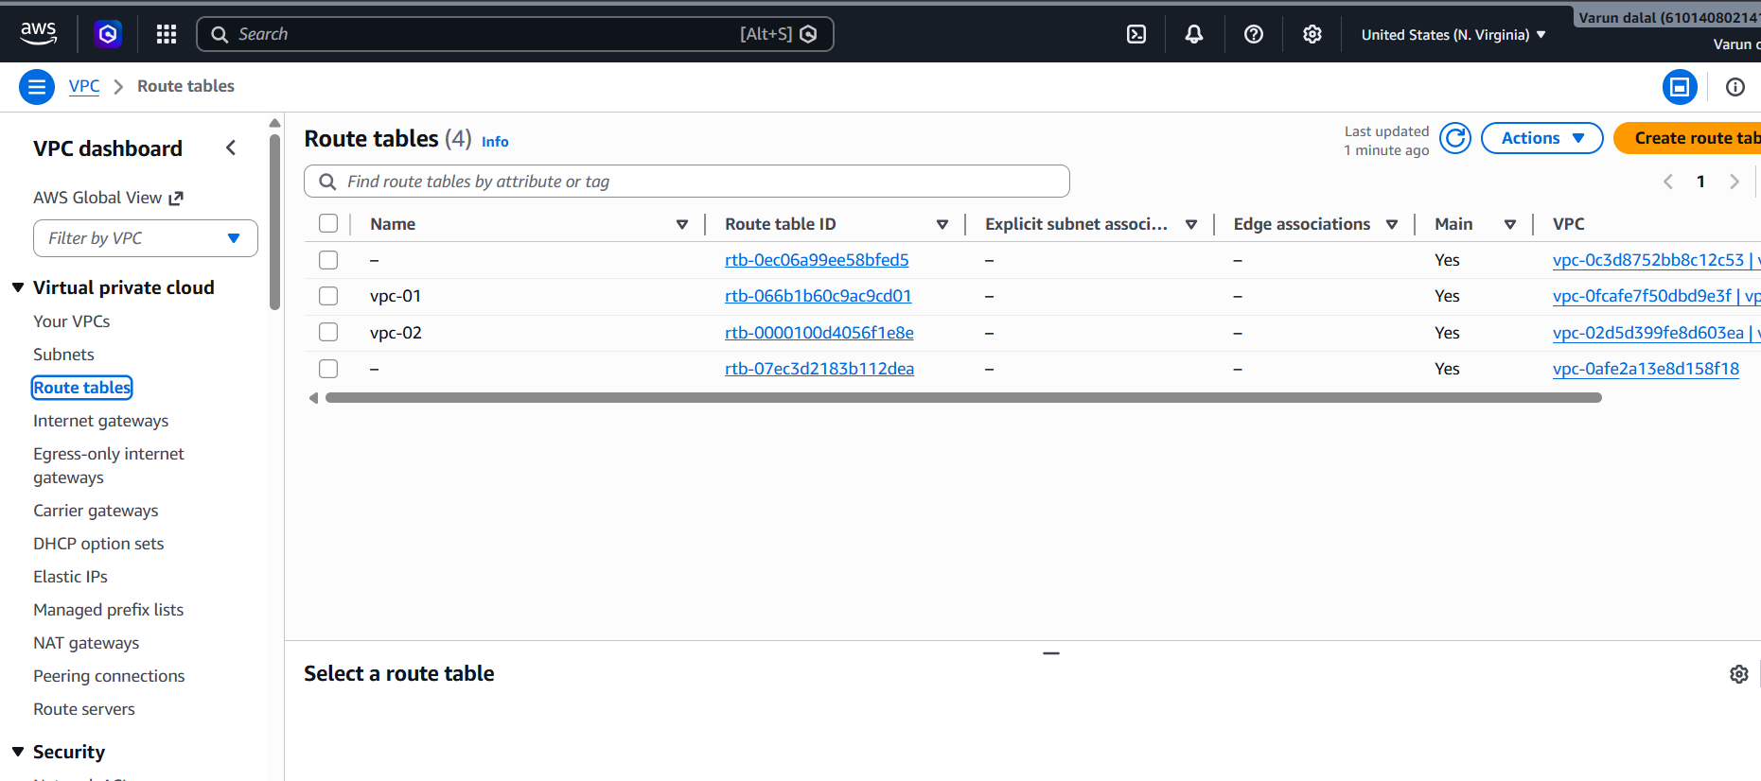
Step 7: Create Transit Gateway
- VPC → Transit Gateways
- Create Transit Gateway
Settings:
Name: My-TGW
DNS Support: Enable
Default Route Table Association: Enable
Default Route Table Propagation: Enable

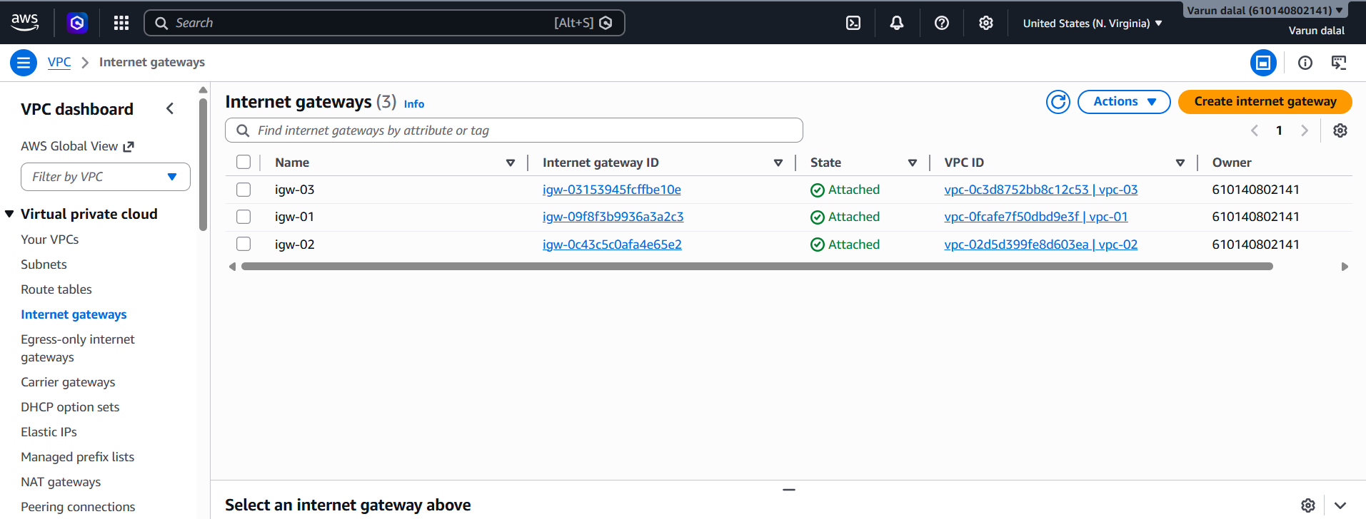
Step 8: Create TGW Attachment for VPC-1
- Transit Gateway Attachments
- Create Attachment
Select:
Attachment Type: VPC
Transit Gateway: My-TGW
VPC: VPC-1
Subnet: 10.0.1.0/24
Step 9: Create TGW Attachment for VPC-2
Select:
VPC: VPC-2
Subnet: 10.1.1.0/24
Create.
Step 10: Create TGW Attachment for VPC-3
Select:
VPC: VPC-3
Subnet: 10.2.1.0/24
Create.
Wait until all attachments show Available
Endpoint created and attached VPC 01 and RT 01
Create VPC Endpoint for S3
Step 16: Create S3 Gateway Endpoint
- VPC → Endpoints
- Create Endpoint
Select:
Service Category: AWS Services
Service Name: com.amazonaws.eu-north-1.s3
Endpoint Type: Gateway
Step 12: Update Route Table of VPC-2
Add routes:
10.0.0.0/16 → Transit Gateway
10.2.0.0/16 → Transit Gateway

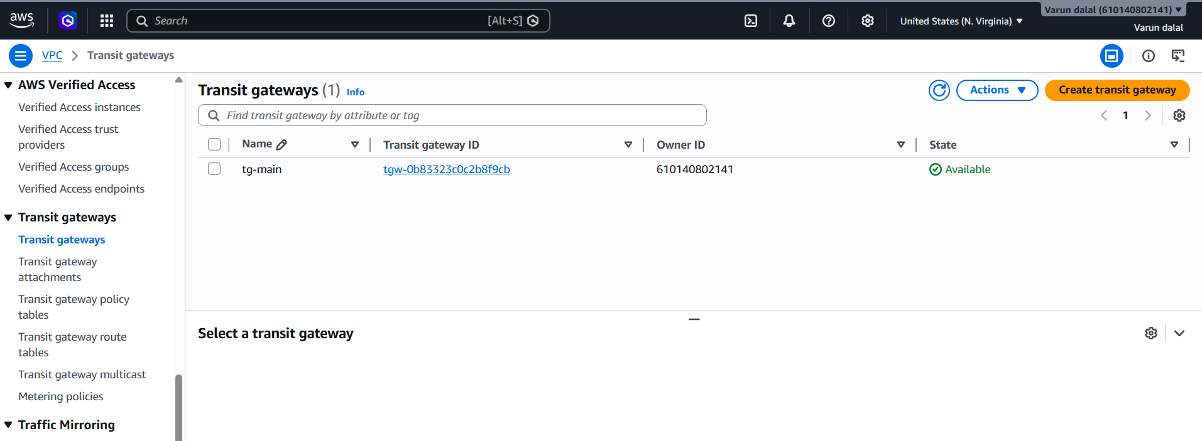
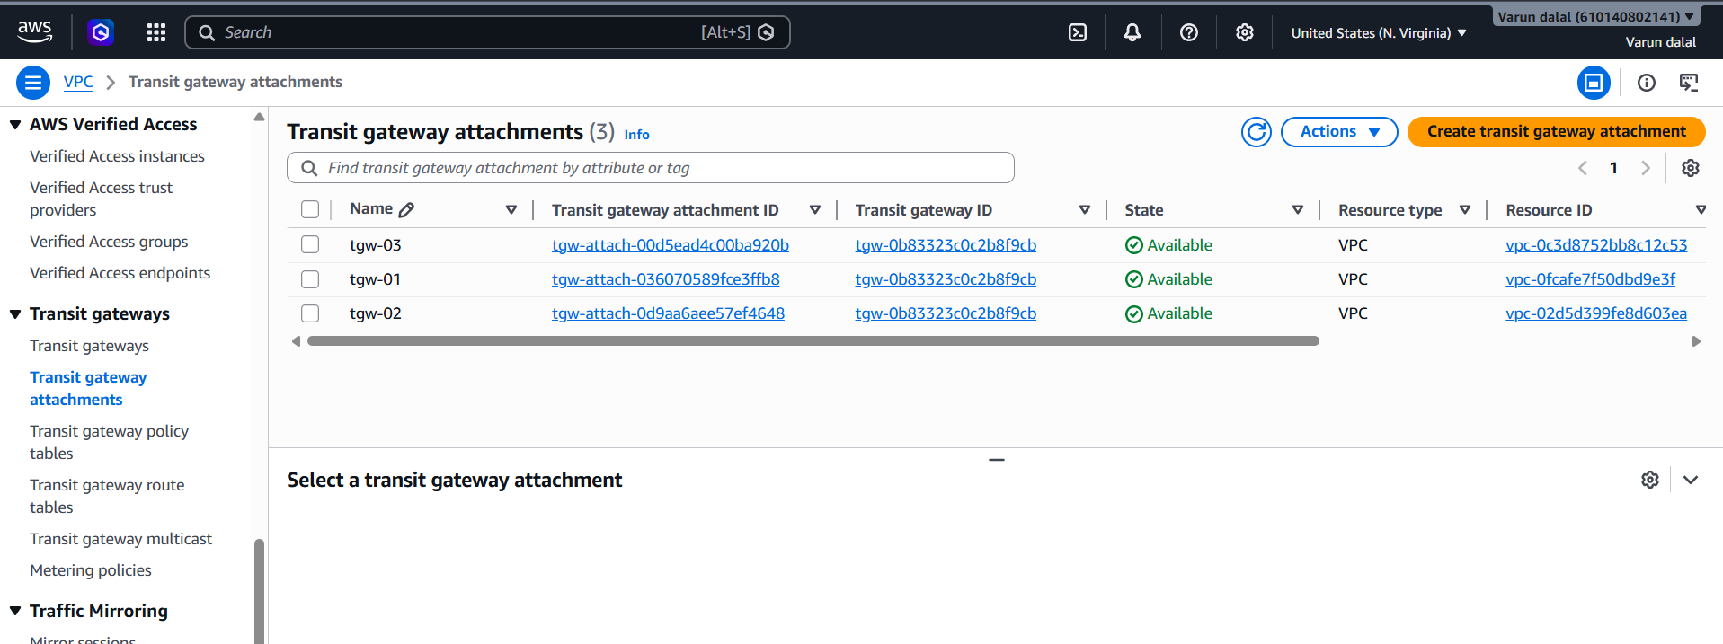 Step 15: Test Transit Gateway
SSH to EC2 in VPC-1:
ping <Private-IP-of-VPC2-EC2>
ping <Private-IP-of-VPC3-EC2>
Ping should succeed.

